
High School Masterclass Information

Saturday, April 11, 2026
UH Moores School of Music
3333 Cullen Blvd
Houston, TX 77004
Online Application Deadline: March 22, 2026

The Houston Flute Club is excited to announce
the High School Masterclass as part of the 2026 Flute Fest
2026 High School Masterclass Rules:
- Applicant must be a current member of the Houston Flute Club at the time of the Flute Fest.
- Applicant must be a high school student.
- No accompanist will be provided.

To apply as a masterclass performer, please submit your application and an MP3 recording (via Google Drive) or YouTube video on our website at www.houstonfluteclub.org:
- Recording Guidelines:
  - Please submit a recording of one piece of your choice as an unedited MP3 file or YouTube unedited video, five to ten minutes maximum, by providing the link from your Google Drive as a shared file, with access to anyone who has the link or the link for your YouTube video. Instructions on how to share a file and to create a link from Google Drive are provided below.
  - The recording may be made with or without accompaniment.
  - The piece performed on recording MUST be the same piece that will be performed at the in-person masterclass on April 11, 2026.
  - The decision of the judges is final.
  - Performers selected for the masterclass will be notified by Saturday, March 28.
- Fees and Membership:
- Application Fee: Free, must be a member of the HFC at time of application
2025–26 HFC Membership Fee:
- $15.00 – Students
- Application Deadline: Must be submitted online no later than 11:59 p.m. on Sunday, March 22, 2026.
Late and/or incomplete applications will not be accepted.

How to share audio files in Google Docs via link:
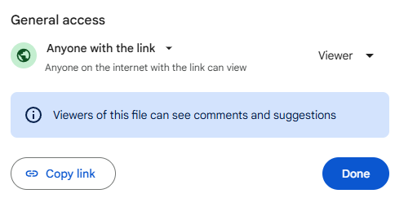
- Select the audio file you want to share.
- Click Share or Share (under the File tab) or right click on the file & select Share.
- Under “General access” click on Copy link.
- Click Copy link.
- Click Done.
- Paste the link in the field on the Application form to share audio file.

